Lara Haase

Experimental Psychology

Cross-modal perception in non-synesthetes

INTRODUCTION

According to Merriam-Webster’s Dictionary, synesthesia is the condition marked by experiencing a sensation other than the one being stimulated. Examples of this are if someone can taste purple, or if each number or letter has its own color. Despite interest in this condition by early psychologists such as Gustav Fechner and Francis Galton, interest in synesthesia faded out with the rise of behaviorism and did not become a popular subject again until the 1980s.

Goller, Otten and Ward (2009) studied synesthetes (people with synesthesia) and compared their reactions to auditory cues with controls. The assessed that the differences between controls and synesthetes occurs early in time and that synesthesia is measurably different from similar effects found and infants and audio-visually induced illusions in adults.

The idea that synesthesia is present at birth but is diminished through normal development is examined by Spector and Maurer (2009) in their article analyzing present theories in synesthesia. They present developmental models and present evidence that the underlying mechanisms of synesthesia are present in all adults.

In their study, Carriere, Eaton, Reynolds, Dixon and Smilek (2009), studied 2 synesthetes eye movements when presented with numbers in different colors. Some of the stimuli were in colors that matched the synesthetes’ normal color perceptions of the numbers, while others were in contradictory colors. In a visual search task, the synesthetes were able to rapidly identify numbers in their complementary colors, but were significantly slower at identifying colors not in the “correct” colors.

Without access to synesthetes to study, the basis for this experiment was to detect similar cross-modal perception in non-synesthetes. It was hypothesized that a low pitch auditory cue would be congruent with a photograph in a low visual field, and that a high pitch auditory cue would be congruent with a photograph in a high visual field. This study was constructed in a Stroop Test fashion, with expectations that incongruent stimuli would result in slower reaction times.

METHODS

*Subjects*

Participants were comprised of 5 undergraduate males and 6 undergraduate females. Six of the participants had musical training while 5 did not.

*Stimuli*

To investigate the possibility of synesthesia related to visual and auditory stimuli, comparable visual stimuli were created as well as auditory. The visual stimuli consisted of a picture of a woman and a picture of a man (Figure 1 and 2 show the original stimuli.) The auditory stimuli created were two piano notes, one low (C) and one high (Bb).

Figure 1- Male stimulus



Figure 2- Female stimulus



*Design/Procedure*

Using Super Lab participants were presented with 200 trials, during which they were asked to respond as fast as possible to whether the person in the picture was male or female. In each trial, the participant was exposed to either a male or female photo, which was placed high on the screen or low on the screen, and a low pitch note or a high pitch note. Each different possibility was presented an equal number of times.

*Measures*

The only dependent variable measured in this study was reaction time, measured in milliseconds. Independent variables included, gender of stimulus, position of stimulus, pitch tone of stimulus, and whether the participant had musical training.

RESULTS

The expected results of this experiment were only half met. It was expected that there would be cross-interaction between the pitch height and the picture position, with a high position and high pitch height resulting in a faster reaction time, as well as a low position and low pitch height resulting in faster reaction time. As seen in Figure 3, an effect was found with the low pitch variable, but not with the high pitch. When subjects were separated by musical experience, those with musical training showed the effect slightly more than those without musical training (see Figures 4 and 5).

Figure 3- Reaction Time of Pitch Height split by Position

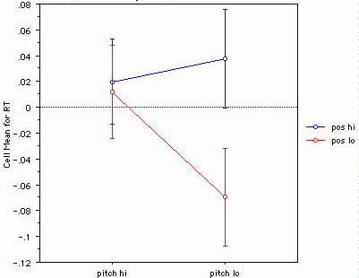

Figure 4- Participants with Musical Training

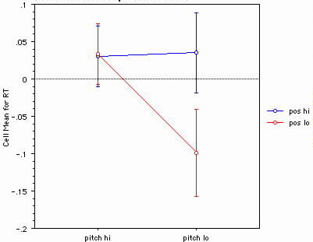

Figure 5- Participants without musical training

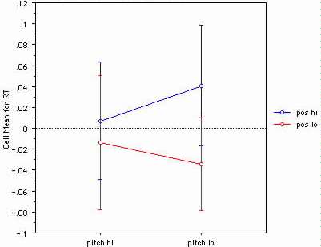

The visual stimuli in this experiment were chosen randomly without regard to the orientation or size of the face in the photograph. This fact may have skewed and largely affected the results. In reference to Figure 1, the male is looking up and facing towards the subjects’ left, while in Figure 2, the female is looking down and facing toward the subjects’ right.

When examining reaction time in relation to gender (and face orientation) and pitch, overall there is no interaction as show in Figure 6. But when broken into musical and non-musical participants, the musically trained subjects show an interaction, but not a significant one (Figure 7). If there were more subjects in the experiment, the interaction could become significant. With non-musically trained subjects however there is no interaction (Figure 8).

Figure 6- Reaction Time of Gender (and face orientation) split by Pitch

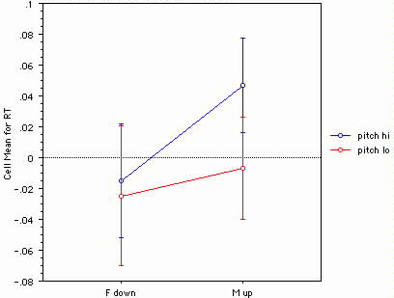

Figure 7- Participants with musical experience

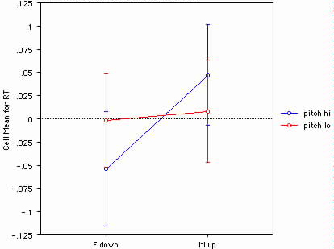

Figure 8- Participants without musical experience

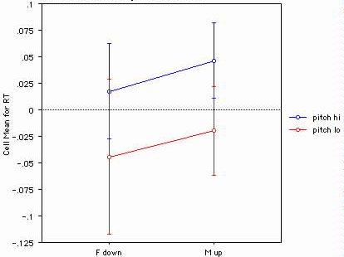

When reaction time was analyzed by gender (face orientation) and position, an interaction was found for the female stimulus but not the male stimulus as seen in Figure 9. But when one particular subject was excluded from the data, an interaction was found for both stimuli (Figure 10).

Figure 9- Reaction time of gender (face orientation) split by Position

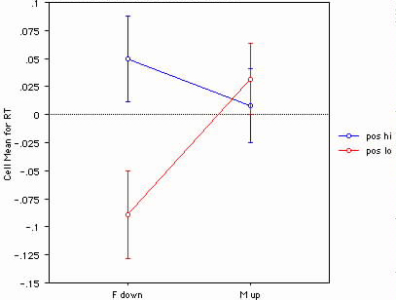

Figure 10- Figure 9 with Subject 5 excluded

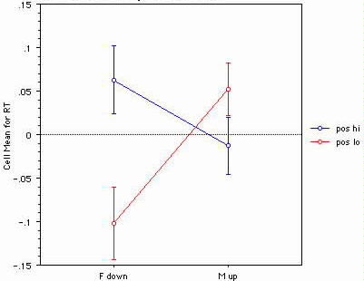

Finally, after analyzing complex variables and interactions, a simple analysis was done of reaction time and position was done (Figure 11). Here it shows that there was a bias among participants to react faster to lower placed stimuli.

Figure 11- Reaction time of Position

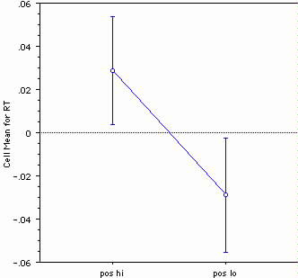

DISCUSSION

There are many possible explanations for the peculiar results of this experiment. Dealing with visual stimuli, the gaze of the person photographed in the stimuli could have greatly influenced the results. It is a major technique in graphic design to place a photo on a page so that the subject is looking into the page versus off of it. This is because the person’s gaze in the photo directs the reader’s attention. There is also a large body of research explaining the use of gaze directed attention in infants for general and language learning purposes. With this knowledge, the fact that the female’s downward gaze placed in a low spatial position makes sense; when she is gazing downward from above it causes the subject to momentarily (in milliseconds) pause to register what is in the lower space. When her downward gaze is directed off the screen from the lower spatial position, the participant knows there is nothing to look at.

Trying to explain the lack of interaction with the male stimulus is much harder. It is likely a result of unequal stimuli than a brain mechanism being exposed. In the stimuli, the female face takes up about two-thirds of the frame, while the male stimulus only occupies about one-third of the frame. This means that the effects of the male interaction were subdued since the participants had to spend longer looking for the face in the photograph amongst more distracting information. As seen in Figure 9 and 10, there is interaction, but it is not as strong in the male stimulus.

The interaction between low pitch height and low picture position was predicted in the original hypothesis, that reaction times would be faster for congruent stimuli. If the hypothesis held completely true, then reaction times would have also been faster for a high pitch note and a high positioned picture, but this was not found. There are a few possible explanations for this. The notes used were a low C note and a high Bb note. The Bb may not have made as much impression as the C; perhaps, it was because the Bb had more overtones that lie in the mean range of the resonant frequency of most human ears. The higher note caused more of a jarring effect as a result of this proximity to the ear’s resonant frequency, which could cause the subjects to hesitate. It may also be that the higher note did not sustain as long, so the participants were not exposed to it as long. Another possible confound may be that the sound was muted or too low for some subjects.

The results found between gender (face orientation) and pitch height do not express significance. The only interaction found (although still insignificant) was reversed from expectations. This may mean that musically trained people (the only ones showing the effect) associate femininity with higher notes.

The fact that participants clearly showed a significantly reaction time for photos in the lower position may have heavily influences the rest of the analyses. The only logical explanation for this preference is that the lower position was closer to eye level and the participants did not have to look around.

One last possible change that could have been made to the experiment could have been to use 100 different photos of women and 100 different photos of men to add variety and eliminate some of the biases created by the stimuli.

REFERENCES

Carriere, J. S., Eaton, D., Reynolds, M. G., Dixon, M. J., & Smile, D. (2009). Grapheme-color synesthesia influence overt visual attention. *Journal of Cognitive Neuroscience*, *21*(2), 246-258.

Goller, A. I., Otten, L. J., & Ward, J. (2009). Seeing sounds and hearing colors: An event-related potential study of auditory–visual synesthesia. *Journal of Cognitive Neuroscience*, *21*(10), 1869-1881.

Spector, F., & Maurer, D. (2009). Synesthesia: A new approach to understanding the development of perception. *Developmental Psychology*, *45*(1), 175-189.